**SAS Enterprise Miner Installation - Part 2**

1. **Running SAS Enterprise Miner**

After completing Part 1 (i.e., creating SAS profile and adding my course), please follow these steps to run SAS Enterprise Miner:

1. Sign on the Control Center at <https://odamid.oda.sas.com>
2. Click SAS Enterprise Miner link which will start downloading a file (e.g., main.jnlp).

Note: please do not save this file because it is not the software. The file’s role is simply initiating SAS Enterprise Miner session. Whenever you want to use SAS OnDemand EM, you need to click the link, download a Java Network Launch Protocol (e.g., main.jnlp), and run it.

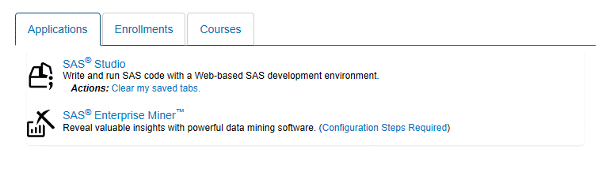

1. Run the downloaded file (e.g., main.jnlp).
2. If JAVA Update window appears, click Later.
3. When you see the following window, click Run

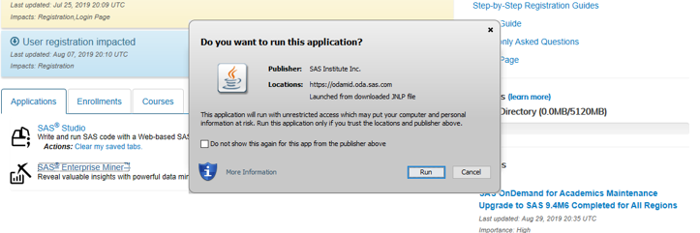

Note: If you cannot run the downloaded file, you need to install the latest Java Runtime Environment (JRE) on your computer. Please refer to SAS EM Installation Part 3.

1. **Creating New Project and Library**

Now let’s create new project:

1. Click Create Project
2. When Step 1 window appears, click Next.
3. Step 2: Enter “PA2020” in Project Name 🡪 Click Next
4. Step 3: Click Next.
5. Step 4: Click Finish.

Now you need to create new library so that you can access course data sets that I have saved to cloud server. Please follow these steps to create new library for course data sets:

1. Click File 🡪 New 🡪 Library
2. When Library Wizard Step 1 window appears, Click Next
3. Step 2: Enter “PAData” in Name and Enter “**/courses/dB7c50m7Wpat0dzu2nyZ2**” in Path. Click Next
4. Step 3: Click Finish

Now you can access all data sets saved in my folder in cloud server. To access a data file, you need to follow the typical steps. Specifically,

File 🡪 New 🡪 Data Source 🡪 Source: SAS Table 🡪 Click Browser 🡪 Click Padata 🡪 Click data file (e.g., Ar_faceplates).

Enjoy!